**Regionalists, The**

The visual artists known as the Regionalists rose to prominence in the United States during the 1930s. They advocated the use of realistic styles to depict the lives and environs of everyday Americans. The most well-known Regionalists were Thomas Hart Benton, Grant Wood, and John Steuart Curry, whose paintings and prints chronicled the agrarian Midwest. During the Great Depression, Regionalism was seen as a comfortingly accessible mode of art. It appeared to celebrate American cultural history using a realistic figural style that repudiated abstraction, which was understood to be a European import. The populist art group Associated American Artists successfully marketed and sold lithographs by many Regionalists to middle-class patrons across the country, thereby extending Regionalism’s influence to those who were not accustomed to owning works of art. The Regionalists’ views of American life were not exclusively flattering, but their approach differed from the critical approach of Social Realists like Ben Shahn or Philip Evergood, whose works illuminated injustices they perceived in contemporary life. The Regionalist heyday drew to a close with the advent of World War II and the development of Abstract Expressionism.

Thomas Hart Benton was born in 1889 into a prominent political family from Missouri. He trained as an artist at the Art Institute of Chicago and the Académie Julian in Paris. In the 1910s, he settled in New York and painted both city life and memories of his rural home state. Benton painted many historical murals, including *America Today* (1930-31) and *A Social History of Missouri* (1936), in which he employed bright colours, dynamic compositions, and rotund figures. His style recalls Old Masters such as Michelangelo and El Greco and incorporates modernist collapsing of space and time. The most outspoken and polemical Regionalist, Benton’s series of murals based on the history of Indiana, commissioned for the 1933 Chicago World’s Fair, caused controversy when Benton included a Ku Klux Klan mob as part of the tableau. Benton justified this inclusion as an effort to tell both the positive and negative aspects of the state’s development. Benton spent fifteen years as an art teacher at the Art Students League in New York (1926-35) and the Kansas City Art Institute (1935-41). Jackson Pollock was among his most famous pupils and modelled for the harmonica player in *The Ballad of the Jealous Lover of Lone Green Valley* (1934). Benton died in 1975.

Grant Wood was born on a farm near Cedar Rapids, Iowa, in 1891. He studied at the Minneapolis School of Design, the University of Iowa, and the Art Institute of Chicago in the 1910s. Apart from sojourns to France and Germany, Wood spent his career as an artist and educator in Iowa. He founded the Stone City Colony and Art School in 1932 and administered Iowa’s division of the New Deal’s Public Works of Art Project (PWAP). Wood’s style is reminiscent of Northern Renaissance painters like Jan van Eyck in its linear precision and stoic arrangement of forms. Wood’s paintings often look artificial because of his use of repetitious geometric shapes and stiff figures. At times, his restrained style enigmatically disguises some of the more poignantly critical or humorous meanings in his work. His most famous painting, *American Gothic* (1930), has always puzzled viewers because it is difficult to discern whether Wood intended to be celebratory or satirical in his presentation of a very serious farmer and daughter. Works like *Parson Weems’ Fable* (1939) and *Daughters of Revolution* (1932) are more convincingly witty in their deconstruction of patriotism in the 1930s. Recent scholarship by R. Tripp Evans has considered the psychological and artistic impact of Wood’s carefully guarded homosexuality. In addition to painting and lithography, Wood designed furniture, stained glass, and other decorative arts, which filled his Cedar Rapids studio. He died of cancer in 1942.

Born in 1897, John Steuart Curry was raised on a farm near Dunavant, Kansas, and studied at the Kansas City Art Institute and the Art Institute of Chicago. Like Benton, Curry moved to New York and built a career there based in large part on reminiscences of his boyhood home. Curry was known for painting epic weather occurrences like floods and tornadoes that impacted on farm life dramatically. In 1936 he became artist-in-residence at the University of Wisconsin’s College of Agriculture. There his task was to foster appreciation for both art and farmers, which he did in heroic works like *Our Good Earth* (1942). Among Curry’s final works was a series of murals for the Kansas State Capitol in Topeka, including *Tragic Prelude*, an image that casts the abolitionist John Brown as a Moses-like martyr of the Bleeding Kansas and Civil War era. A dispute with the state legislature led Curry to leave the project unfinished at the time of his death in 1946.

Regionalism is also sometimes known as American Scene painting, a broader term that incorporates any artist interested in depicting local or regional culture. Apart from the three major Midwestern Regionalists, painters like Joe Jones (of Missouri), Alexandre Hogue and Jerry Bywaters (of the Dallas Nine), and Paul Sample (of Texas) painted rural scenes during the 1930s. Charles Sheeler and Charles Demuth paid tribute to their native rural Pennsylvania during this period, as well. Even Edward Hopper (of New York), Andrew Wyeth (of Pennsylvania), and Charles Burchfield (of Ohio) may be counted as part of this larger cultural impulse, pervasive in the interwar United States, to investigate one’s local history and terrain as fodder for an art career.

**List of works**

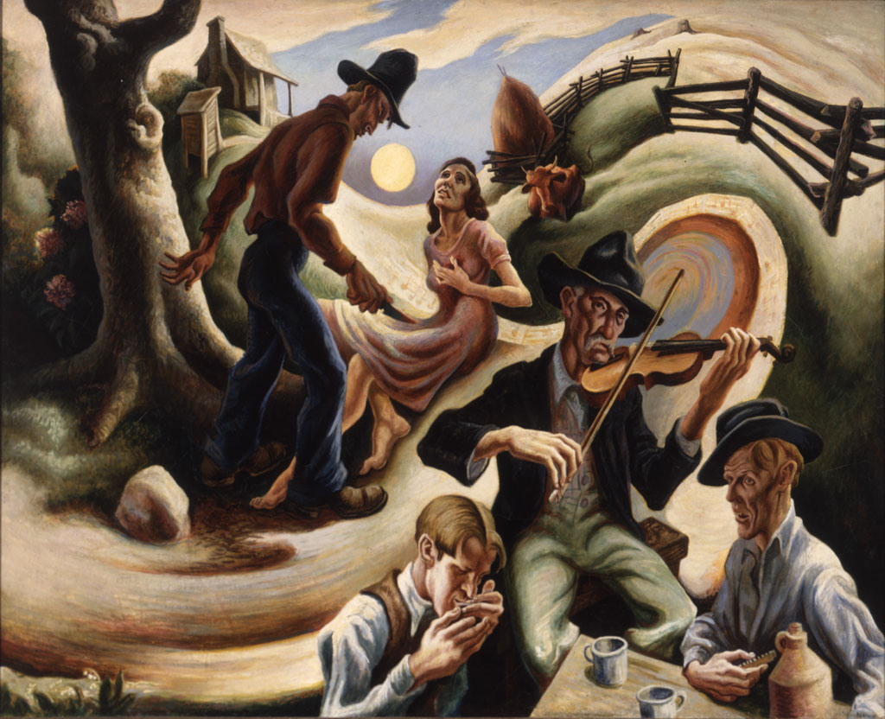

Thomas Hart Benton, *The Ballad of the Jealous Lover of Lone Green Valley*, 1934, oil and tempera on canvas mounted on aluminum panel. Spencer Museum of Art, University of Kansas <http://collection.spencerart.ku.edu/eMuseumPlus?service=ExternalInterface&module=collection&objectId=9953>

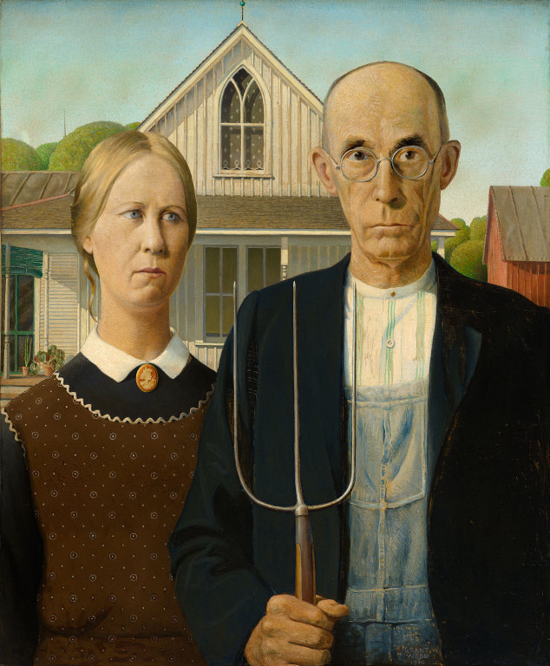

Grant Wook, *American Gothic*, 1930. Oil on Beaver Board. 78 x 65.3 cm (30 3/4 x 25 3/4 in.). Art Institute of Chicago. <http://www.artic.edu/aic/collections/artwork/6565>

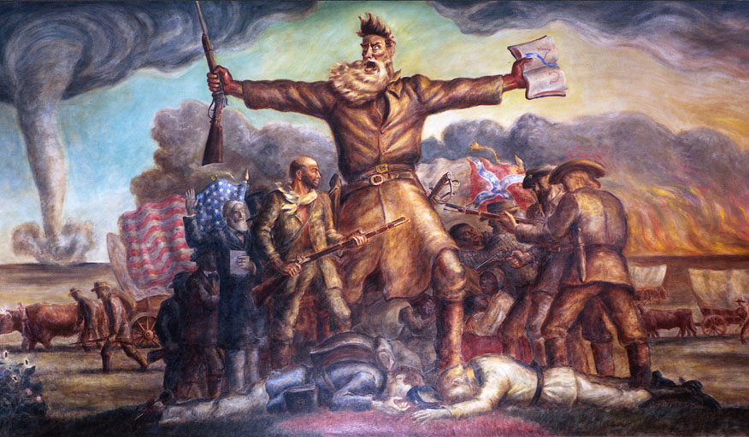

John Steuart Curry, *Tragic Prelude*, 1938-1940. Kansas State Capitol, Topeka, KS.

<http://www.kshs.org/p/kansas-state-capitol-online-tour-tragic-prelude/16595>

<http://en.wikipedia.org/wiki/File:John_Brown_Painting.JPG>

**References and further reading**

Adams, H. (1989) *Thomas Hart Benton: An American Original*. New York: Knopf.

Baigell, M. (1974) *The American Scene: American Painting from the 1930s*. New York: Praeger.

Corn, W. (1983) *Grant Wood: The Regionalist Vision*. New Haven, CT: Minneapolis Institute of Arts, in association with Yale University Press.

Dennis, J. (1998) *Renegade Regionalists: The Modern Independence of Grant Wood, Thomas Hart Benton, and John Steuart Curry*. Madison: The University of Wisconsin Press.

Evans, R. T. (2010) *Grant Wood: A Life*. New York: Knopf.

Junker, P. (ed.) (1998) *John Steuart Curry: Inventing the Middle West*. New York: Hudson Hills Press.

Kendall, M.S. (1986) *Rethinking Regionalism: John Steuart Curry and the Kansas Mural Controversy*. Washington, DC: Smithsonian Institution Press.

Milosch, J. ed. (2005) *Grant Wood’s Studio: Birthplace of American Gothic*. New York: Prestel.